EE4902 Part 2 Assignment 1

Name: Lim Jia Song John

Matriculation No.: U1321554J

# Derive the **grayscale transformation $s=T(r)$** for contrast stretching.

The transformation function for linear contrast stretching is as follows:

Let ‘r’ be the pixel in the original image and ‘s’ is the pixel in the contrast stretched image. In a grayscale image, a pixel’s value ranges from 0 to 255.

Let the original image contain:

$$r_{min}=\min\left\{f\left(x,y\right)\right\}, the lowest \left(darkest\right) pixel value$$

$$r_{max}=\max\left\{f\left(x,y\right)\right\}, the lowest \left(darkest\right) pixel value$$

In low contrast images,

$$r_{max}-r_{min}≪255$$

Let the enhanced image be $g(x,y)$ having $[s_{min}, s_{max}]$

To linearly map f to g:

$$\frac{g\left(x,y\right)- s_{min}}{s_{max}-s_{min}}=\frac{f\left(x,y\right)-r_{min}}{r_{max}-r_{min}}$$

Since $s_{min}=0 and s_{max}=255$, the enhanced pixel value is:

$$g\left(x,y\right)=255×\frac{f\left(x,y\right)-r_{min}}{r_{max}-r_{min}}$$

# Experiment contrast stretching for images using the web site below.

Code in Matlab was implemented to transform the image pixels. The code used is as follows:

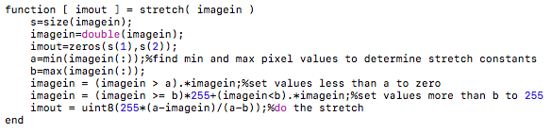

The contrast stretched images were then compared with the original image and the results are presented as follows:

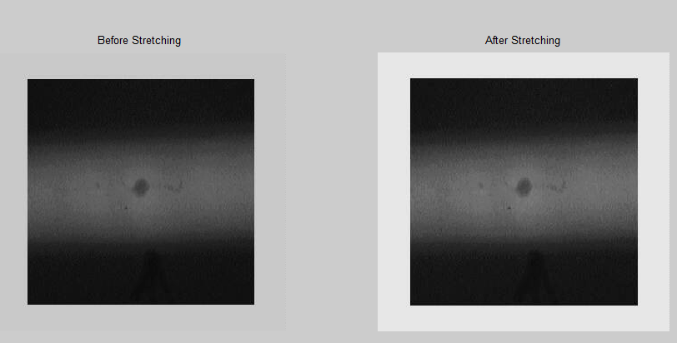

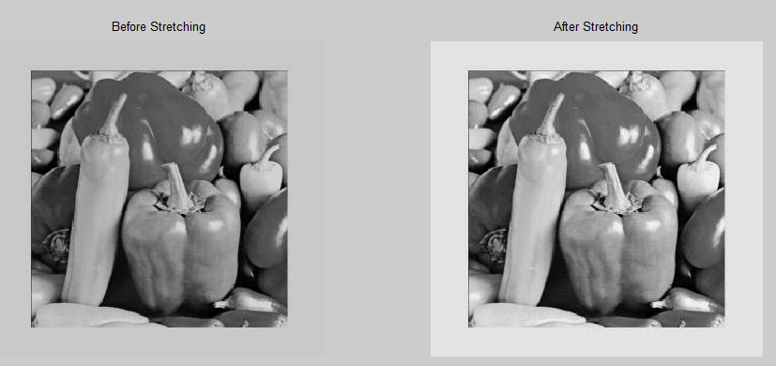

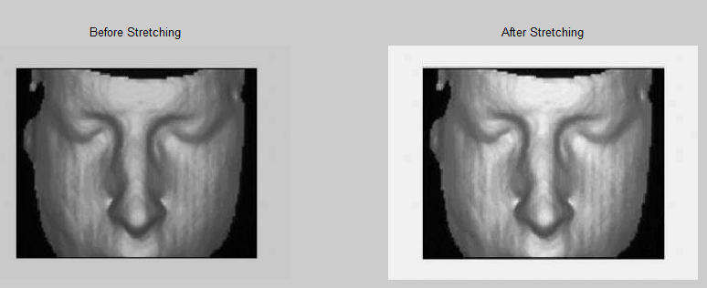

To further analyze the effect of contrast stretching, the histogram of the image was obtained. A low contrast image was generated by dividing the original image pixels by two, and then adding an offset of 80.

|  |  |
| --- | --- |
| Low contrast image | Histogram |
|  |  |

|  |  |
| --- | --- |
| Contrast stretched image | Histogram |
|  |  |

As evidenced by the histogram of the two images, contrast stretching will evenly distribute the pixels across a larger dynamic range, resulting in a better contrast.